# CS 255 System Design Document

Travis Waggoner

## UML Diagrams

### UML Use Case Diagram

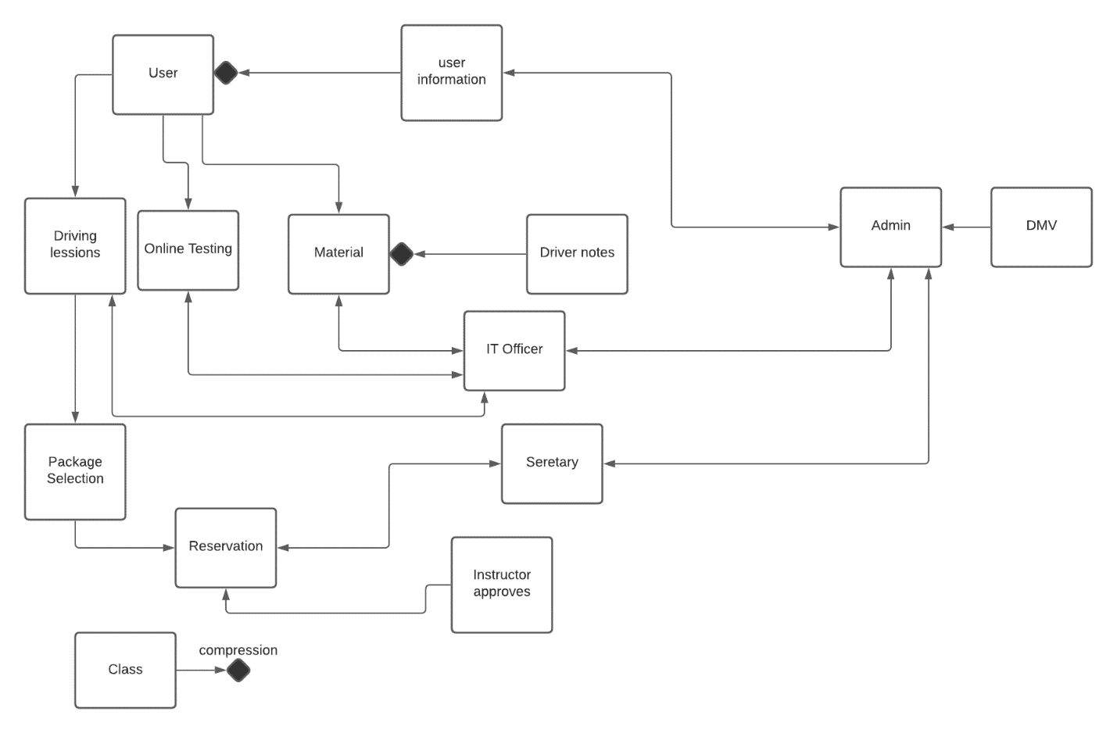

### UML Activity Diagrams

### UML Sequence Diagram

### UML Class Diagram

## Technical Requirements

*The requirements for this program will be web-Based focused. This will require the program to be able to run on any operating system and web browser. Some hardware requirements will be dedicated servers to run and maintain the overall program. This will allow for local access to the material and program to make corrections and changes as needed. The software that needs to be aware of will be the android and IOS operation systems while creating applications so the user may download and study the material. The tools that will be needed is a understanding of operation systems servers and user security. The overall infrastructure will be local to the team running the program and requires human interactions for corrections within the system. This will be important because of the in-person interactions of the driving lesion and the issues that can arrive because of this.*